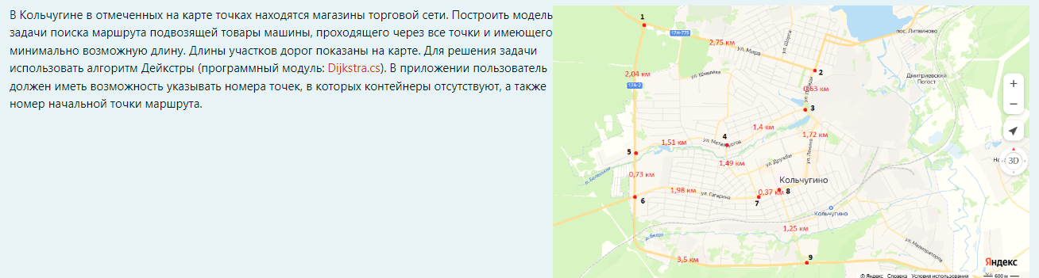

Представлен граф с 9 вершинами V = {v1, v2, v3, v4, v5, v6, v7, v8, v9} и рёбрами E = { v1 v2, v2 v3, v3 v4, v4 v5, v5 v6, v6 v7, v7 v8, v8 v9, v6 v9} = {e1, e2, e3, e4, e5, e6, e7, e8, e9}.

Матрица инцидентности:

|  |  |  |  |  |  |  |  |  |  |
| --- | --- | --- | --- | --- | --- | --- | --- | --- | --- |
|  | e1 | e2 | e3 | e4 | e5 | e6 | e7 | e8 | e9 |
| v1 | 1 | 0 | 0 | 0 | 0 | 0 | 0 | 0 | 0 |
| v2 | 1 | 1 | 0 | 0 | 0 | 0 | 0 | 0 | 0 |
| v3 | 0 | 1 | 1 | 0 | 0 | 0 | 0 | 0 | 0 |
| v4 | 0 | 0 | 1 | 1 | 0 | 0 | 0 | 0 | 0 |
| v5 | 0 | 0 | 0 | 1 | 1 | 0 | 0 | 0 | 0 |
| v6 | 0 | 0 | 0 | 0 | 1 | 1 | 0 | 0 | 1 |
| v7 | 0 | 0 | 0 | 0 | 0 | 1 | 1 | 0 | 0 |
| v8 | 0 | 0 | 0 | 0 | 0 | 0 | 1 | 1 | 0 |
| v9 | 0 | 0 | 0 | 0 | 0 | 0 | 0 | 1 | 1 |

|  |  |  |  |  |  |  |  |  |  |
| --- | --- | --- | --- | --- | --- | --- | --- | --- | --- |
|  | v1 | v2 | v3 | v4 | v5 | v6 | v7 | v8 | v9 |
| v1 | 0 | 2.75 | 0 | 0 | 0 | 0 | 0 | 0 | 0 |
| v2 | 2.75 | 0 | 0.63 | 0 | 0 | 0 | 0 | 0 | 0 |
| v3 | 0 | 0.63 | 0 | 1.4 | 0 | 0 | 0 | 0 | 0 |
| v4 | 0 | 0 | 1.4 | 0 | 1.51 | 0 | 0 | 0 | 0 |
| v5 | 0 | 0 | 0 | 1.51 | 0 | 0.73 | 0 | 0 | 0 |
| v6 | 0 | 0 | 0 | 0 | 0.73 | 0 | 1.98 | 0 | 3.5 |
| v7 | 0 | 0 | 0 | 0 | 0 | 1.98 | 0 | 0.37 | 0 |
| v8 | 0 | 0 | 0 | 0 | 0 | 0 | 0.37 | 0 | 1.25 |
| v9 | 0 | 0 | 0 | 0 | 0 | 3.5 | 0 | 1.25 | 0 |